**Persisting Arrays**

Persisting arrays is similar to persisting lists, so we will only breeze through the mechanic and will not delve into too much detail here. The *Showroom* class now has variable, cars*,* of the *String* array type, as listed here:

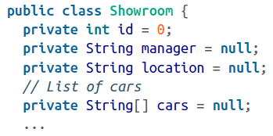

The mapping of the classes is defined here:

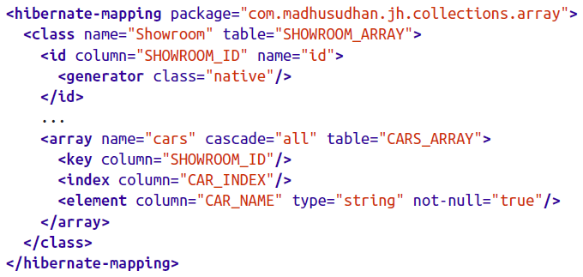

The *array* tag defines the mapping between the *cars* variable and the CARS_ARRAY table. As expected, the CARS_ARRAY table will have a foreign key (SHOWROOM_ID, in this case). Hibernate also preserves the insertion order; hence, index tag must be defined with a name. *element* defines the actual values composing the array – in this case, the model name of each car.

The *persistArrays* method on our test class (shown next) would persist the relevant arrays in the database. We create the *String[]* of cars, passing in the model names, as shown in the following snippet:

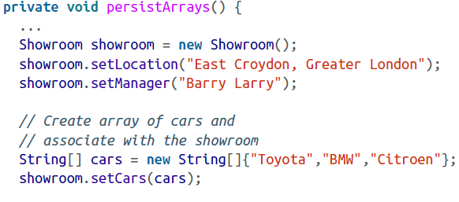

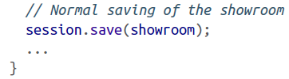

The *retrieveArray* method on the test client would fetch the cars as expected:

